FieldWorks
Data Notebook

Exercises



Copyright © 2002-2008 SIL International

Contents
Contents 2
Introduction 4
Module ED: Entering Data 5
Exercise ED-1: Adding an event entry 5
Exercise ED-2: Adding a subentry 6
Exercise ED-3: Adding another subentry 7
Exercise ED-4: Adding another subentry 9
Exercise ED-5: Adding another subentry 11
Module BR: Using Backup and Restore 13
Module VN: Using Views and Navigation 14
Module TP: Tracking People and Places 15
Exercise TP-1: Entering the location 15
Exercise TP-2: Entering the location 16
Exercise TP-3: Entering the participants 17
Module SD: Sorting Data 18
Exercise SD-1: Applying standard sort methods 18
Exercise SD-2: Creating a sort method 18
Module RT: Referencing Different Types Of Data 19
Exercise RT-1: Conversation 19
Exercise RT-2: Interview 20
Module OE: External Data and Links 21
Exercise OE-1: Literature Summary 21
Exercise OE-2: Referencing diagrams and artifacts 22
Exercise OE-3: Inserting hyperlinks to image files 23
Exercise OE-4: Inserting hyperlinks to documents 24
Module DM: Dealing With Multilanguage Data 25
Exercise DM-1: Entering vernacular text 25
Exercise DM-2: Entering text in another language 26
Module AD: Altering Data 28
Exercise AD-1: Adding text 28
Exercise AD-2: Deleting and adding text 29
Module DQ: Using Your Data to Generate Research Questions 30
Exercise DQ-1: Entering questions 30
Exercise DQ-2: Entering questions 31
Module CE: Categorizing Entries 32
Exercise CE-1: Adding OCM codes 32
Exercise CE-2: Adding OCM codes 33
Exercise CE-3: Adding more OCM codes (optional) 33
Module OL: Identifying Data with Overlays 34
Exercise OL-1: Tagging texts with overlays 34
Exercise OL-2: Tagging texts with overlays 35
Module AS: Adding Supporting Evidence 36
Exercise AS-1: Adding supporting evidence 36
Exercise AS-2: Adding supporting evidence 37
Module BF: Using Basic Filters to Find Data 38
Exercise BF-1: Applying a basic filter 38
Exercise BF-2: Creating a basic filter 38
Module AF: Adding and Using Advanced Filters 39
Exercise AF-1: Creating an advanced filter 39
Exercise AF-2: Creating an advanced filter 40

Introduction
FieldWorks Data Notebook is a data management tool for language and cultural fieldwork.
In this training course, you spend at least half of your time actually practicing the skills using realistic data. In each module in the Student Manual, follow the numbered steps and check your work using the pictures. For more practice, do these exercises.

Opening course documents
The course includes the following documents: Student Manual, Exercises, Copy-and-paste Data, and Instructor Guide. To open a document (for example, Exercises), do either of the following:
- On the Help menu of Data Notebook, point to Training, and then click Exercises.
- In Windows Explorer, double-click the DN Exercises.doc file.
By default, it is installed in the following folder:
C:\Program Files\SIL\FieldWorks\Data Notebook\Training

Module ED: Entering Data

Exercise ED-1: Adding an event entry
Add the following event entry from September 13, 2001. Title it Meeting new people
After we were introduced to everyone and we talked briefly, others began to come - mostly children - but Nathan, the Lela pastor arrived and welcomed us as well. He didn't stay terribly long - they mainly discussed the musical group from Barsa that is coming for the service tomorrow but that no one here knew about.
After unpacking we sat down to supper (Mark went into town to eat with the people he's been eating with while Elsa has been gone). Paul (who is Mark's uncle - FB) came. He is the Teli pastor. Elsa showed him the printed out Teli Scripture portions from Romans, Matthew (I think) and Genesis. He was obviously delighted and began reading them right away. He speaks little French so I know little of what the conversation was about. Elsa did say later that there were no apparent problems right now.
We turned in just after 9 p.m. and I slept better than I ever remember. I woke this morning at 6 with the chickens - and a goat walking across the cistern roof!
Create this entry on your own. When you have finished, it should look like the example below.
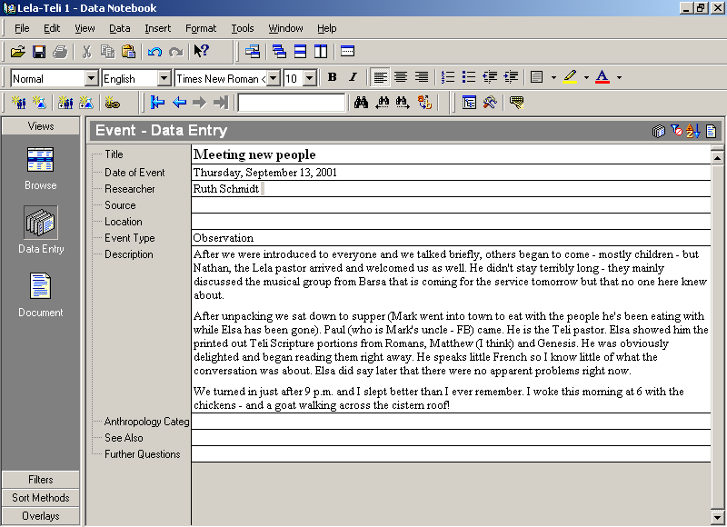

Exercise ED-2: Adding a subentry
Add another subentry to the main entry First funeral. Title it First impressions and date it September 14, 2001. Ruth is the Researcher.
We went over and greeted some men. The husband of the dead woman came nearby and Mark presented our condolences and gave him 100 cfa (mine) then we went down near the dead woman. She was in a gbarma (chair) with a scarf on her head and one tying her chin up. She wore small lip plugs. A pagne covered her. In her lap was a calabash with plates and 3-4 times men came and dropped cowries into the calabash. Women were crying (3-4 actually and the rest moaning). About 50 women were seated around. A man was playing the balafon. Eventually 2 men joined him on drums and one hitting a hoe. 3 men, one at a time came and stood by the balafon and talked. The first had a coin (10 cfa) that Mark had given him and he held it up and talked and dropped it on the balafon. The other 2 were sons or very close relatives. They held cowries and dropped the shells on the balafon as they talked. They would speak and the balafon would play. M said the balafon talked translating what they said.
Create this entry on your own. When you have finished and scrolled to the top of the main entry, it should look like the example below.

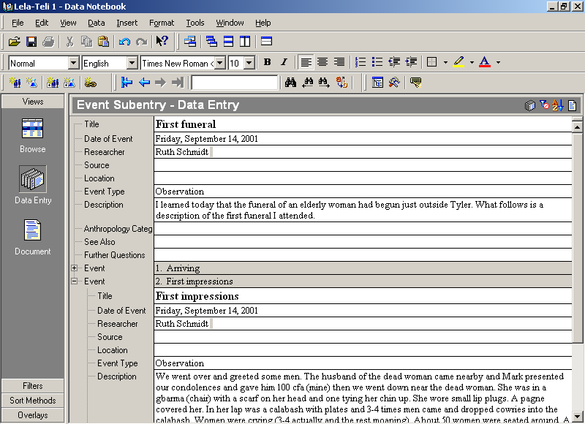

Exercise ED-3: Adding another subentry
Add another event subentry to the main entry First funeral. Title it The women dance. Ruth is the Researcher. The date of the event is September 14, 2001.
Before you start, click the - to the left of the second event subentry name to collapse the First impressions subentry. Make sure you click in the Title field of the main entry before creating the new subentry.
After the last one had spoken and dropped his shells some of the women got up and began to dance. Eventually the majority did. Some of the women had leaves tied at their waists covering their backsides - maybe 8-10 of them. They would run out away from the body, dance a bit and then move back in close. It seemed to be the ones crying hardest who drew the closest. The drums, hoe and balafon were much louder now. Some of the women would reach down and stroke the woman's shoulders and rearrange the pagne. M says none of these things are buried with the body. I think he said nothing, not even a ring (or just a ring?) is buried with the body. They are buried naked as they were born. The village burial plot is a hole dug down and then a gallery dug out where up to 15 may be buried.

Create this entry on your own. When you have finished and scrolled to the top of the main entry, it should look like the example on the next page.
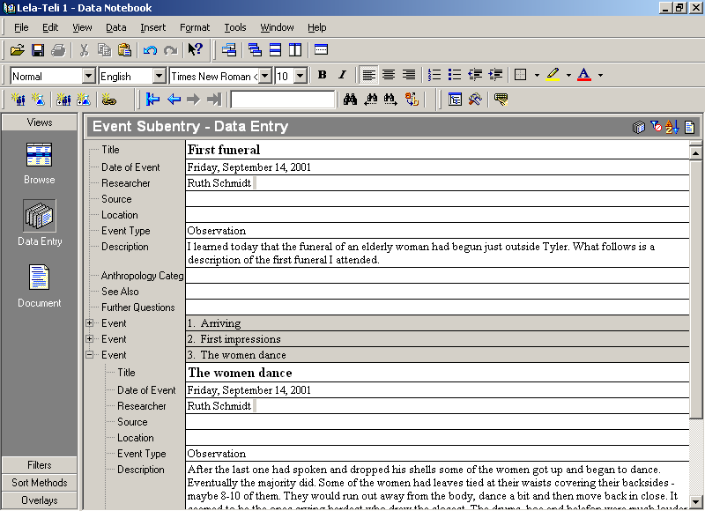

Exercise ED-4: Adding another subentry
Add another event subentry to the main entry First funeral. Title it Who's attending? Ruth is the Researcher. The date of the event is September 14, 2001.
Before you start, click the - to the left of the third event subentry name to collapse The women dance subentry. Make sure you click in the Title field of the main entry before creating the new subentry.
As I sit here writing there are still mostly women by the body except for those playing the instruments. The guns have gone off about 5 times. There are mostly men up on the rocks we are on. More men, women and lots of children are in various clusters of trees and rocks nearby. Maybe 200 or more with the women crying. There are now about 100 people around the deceased chanting. People are still arriving. Many of the men have come on bicycles. A large group of women have run from the deceased, stop and dance a bit then run again, doing this a couple of times around the body.

Create this entry on your own. When you have finished and scrolled to the top of the main entry, it should look like the example on the next page.
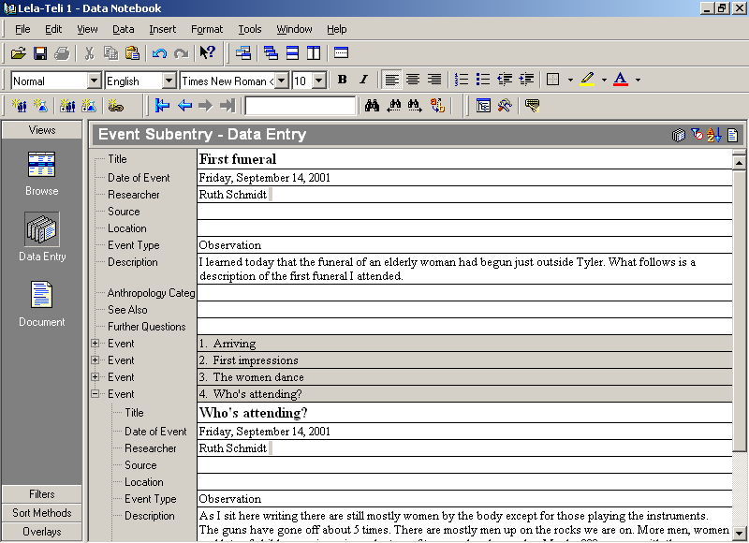

Exercise ED-5: Adding another subentry
Add another event subentry to the main entry First funeral. Title it The widower. Ruth is the Researcher. The date of the event is September 14, 2001.
Before you start, click the - to the left of the fourth event subentry name to collapse the Who’s attending? subentry. Make sure you click in the Title field of the main entry before creating the new subentry.
The widower was just led up from the body. He has white dried mud (?) (caolin) spread over his body. M says after the internment he'll wash it off. Then 2 days later they'll consult the fetish to see if the soul rests. If yes, he'll put back on the caolin and keep it for up to a year. If the soul does not rest he won't put it on again. He says it used to be about 50% of the time that they put it on again but the world has gotten so bad that only about 10% do now. 3:05 The husband of the dead woman just passed. He has on red mid-thigh shorts, the caolin and then leaves tied on front and back like they used to wear.

Create this entry on your own. When you have finished and scrolled to the top of the main entry, it should look like the example on the next page.
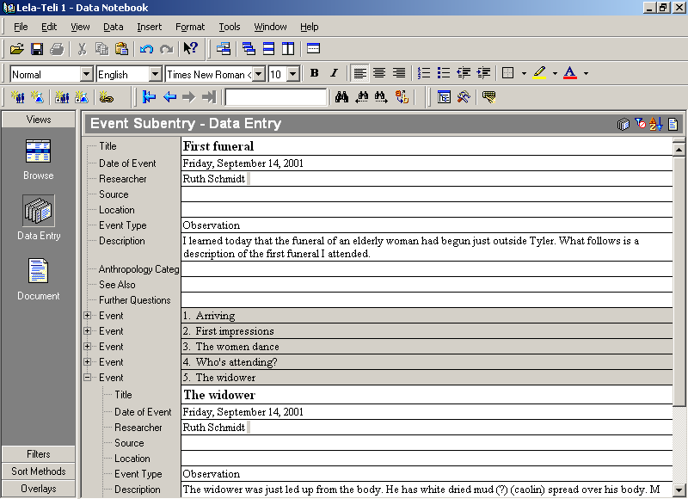

Click the - to the left of the fifth event subentry name to collapse The widower subentry.

Module BR: Using Backup and Restore
As you work thorough this course, you may want to experiment with a particular project. To preserve the ability to come back to an original project the way it was initially delivered to you, complete the following.
      - Back up the Lela-Teli 1 project.
      - Back up the Lela-Teli 2 project.
      - Back up the Lela-Teli 3 project.

Module VN: Using Views and Navigation
      - Navigate to the first entry in the Lela-Teli 1 project.
      - While in entry 1 switch to the Document view.
      - Turn on the Full Window view.
      - Turn off the Full Window view.
      - Switch to the Browse view.
      - Move to entry 2. If the Missing Data dialog box appears, click No to All.
      - Switch to the Data Entry view.
      - Navigate to the last entry in the Lela-Teli 1 project.

Module TP: Tracking People and Places

Exercise TP-1: Entering the location
Finish filling in the event entry titled Picking cotton. It is dated September 19, 2001. The location is Mark’s cotton field. Ruth is the researcher.
When you have finished, it should look like the example below. If you desire, you can fill in more fields using skills learned in other modules. Additional information is not provided.
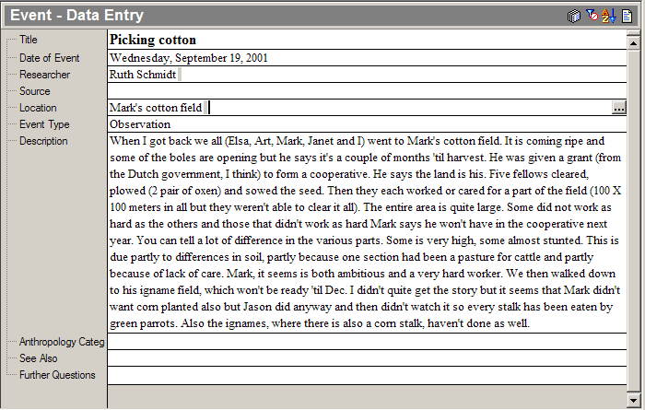

Exercise TP-2: Entering the location
Finish filling in the event entry titled Musical instrument. It is dated September 20, 2001. The location is Ev’s Compound. Ruth is the researcher.
When you have finished, it should look like the example below. If you desire, you can fill in more fields using skills learned in other modules. Additional information is not provided.
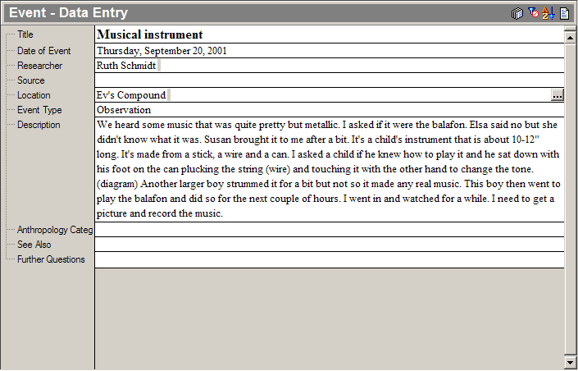

Exercise TP-3: Entering the participants
Finish filling in the event entry titled Knee jangles. It is dated September 23, 2001. The location is Tyler. Lester is the source. Simon and Kora are participants. Ruth is the researcher.
When you have finished, it should look like the example below. If you desire, you can fill in more fields using skills learned in other modules. Additional information is not provided.
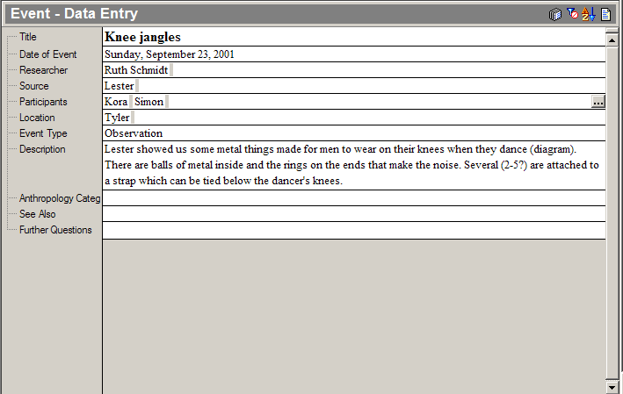

Module SD: Sorting Data

Exercise SD-1: Applying standard sort methods
      - Using what you have learned, sort the Lela-Teli 3 project using the sort methods that were supplied with the language project (that is, Date of Event, Location, Source).
      - When you are done, make sure you turn on the Default Sort.
      - Make sure you are in the Data Entry view at the first entry in the project.

Exercise SD-2: Creating a sort method
Create a new sort method called Location and Source. The primary sort should be by Location and the secondary sort should be by Source. When you are done creating the sort method, your dialog box should look like the following illustration.
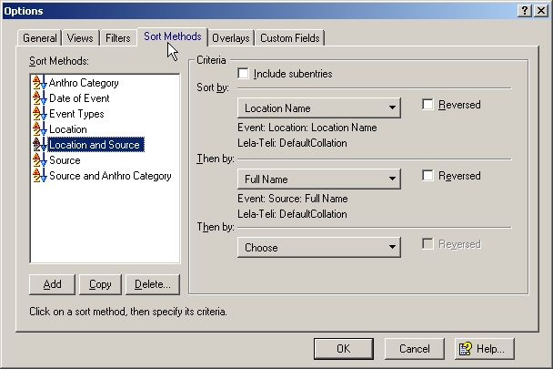

      - Apply your new Location and Source sort method and review the results.
      - Apply the Source sort method and review the results.
      - Note how the results are different from the Location and Source sort method that you created.
      - When you are done, make sure you turn on the Default Sort.
      - Make sure you are in the Data Entry view at the first entry in the project.

Module RT: Referencing Different Types Of Data

Exercise RT-1: Conversation
Find the Event Entry titled Most people have done wrong. It is dated 14 September 2001. Choose Conversation as the Event Type.
When you have finished, it should look like the example below. If you desire, you can fill in more fields using skills learned in other modules. Additional information is not provided.
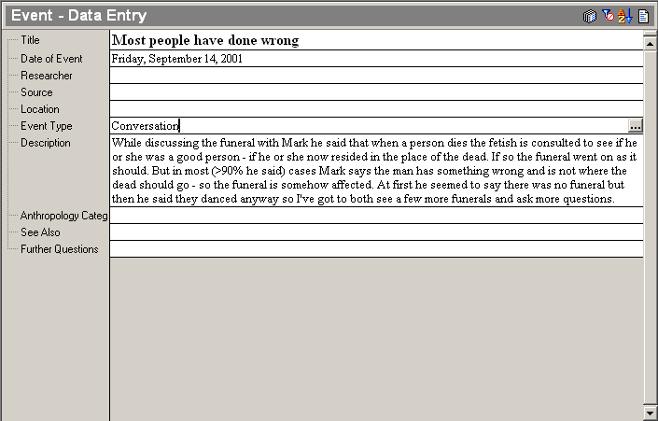

Exercise RT-2: Interview
Find the Event Entry titled Burial of an old Christian man. It is dated 17 January 2002. Choose Interview as the Event Type.
When you have finished, it should look like the example below. If you desire, you can fill in more fields using skills learned in other modules. Additional information is not provided.
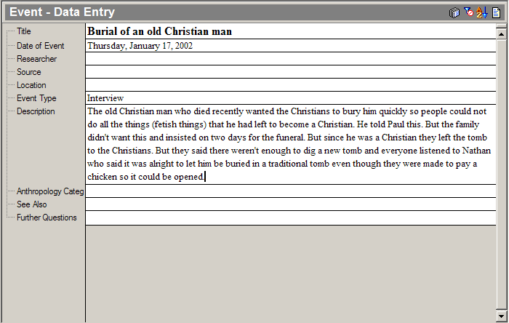

Module OE: External Data and Links

Exercise OE-1: Literature Summary
Find the entry titled The matriclan and the patriclan. It is dated 30 December 2001. Change its event type to Literature Summary. Show the External Materials field, and then type Felton p. 41-42.
When you have finished, it should look like the example below. If you desire, you can fill in more fields using skills learned in other modules. Additional information is not provided. Note that the last four sentences have been removed from the description so you can see the entire entry.
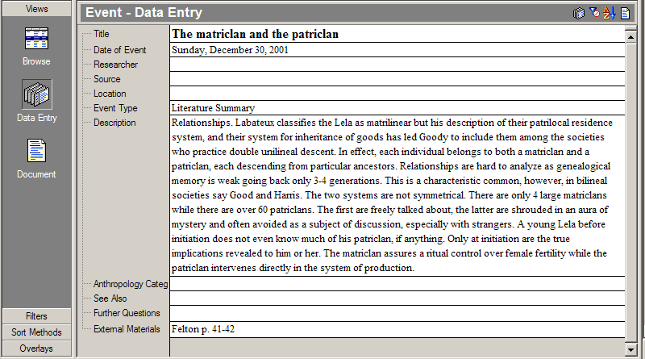

Exercise OE-2: Referencing diagrams and artifacts
Find the entry titled Dancing accessories for men. It is dated 28 March 2002. Show the External Materials field, and then type the following sentence.
The diagram of Mark’s knee jangles is in drawing book 1, page 12; the jangles themselves are in my artifact box in Abada.
Add the information.
When you have finished, it should look like the example below. If you desire, you can fill in more fields using skills learned in other modules. Additional information is not provided.

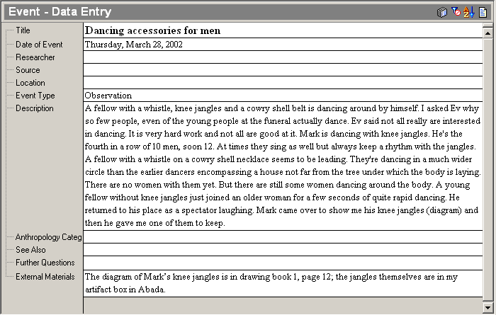

Exercise OE-3: Inserting hyperlinks to image files
Find the entry titled Tombs. It is dated 6 March 2002. Change the event type to Interview. Show the External Materials field and type the following Tomb picture. Add a hyperlink to the tomb.jpg file.
Tip: The file is in the following folder:
C:\Program Files\SIL\FieldWorks\Data Notebook\Training\Pictures
When you have finished, it should look like the example below. If you desire, you can fill in more fields using skills learned in other modules. Additional information is not provided. Note that the last paragraph has been removed from the description so you can see the entire entry.
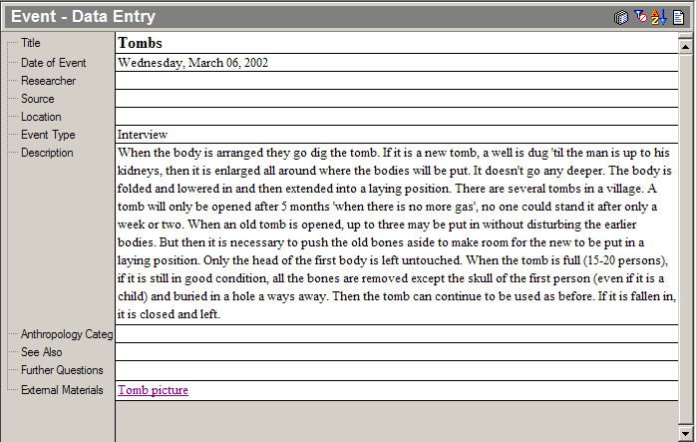

Exercise OE-4: Inserting hyperlinks to documents
Find the entry titled A look at the Tyler church. It is dated 31 August 2002. This is an analysis entry. Show the External Materials field, and then type Tyler church profile including tables. Add a hyperlink to the Profile of the Tyler church.doc file.
Hint: The file is in the following folder:
C:\Program Files\SIL\FieldWorks\Data Notebook\Training\Pictures
When you have finished, it should look like the example below. You will notice the date of event does not appear in the entry, because it is an analysis entry. If you use the Browse view and scroll by date, you can quickly find the entry even though no date is visible.
If you desire, you can fill in more fields using skills learned in other modules. Additional information is not provided.
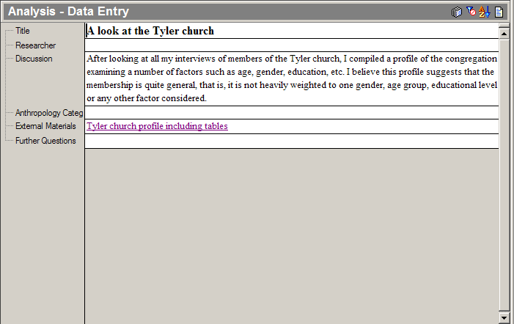

Module DM: Dealing With Multilanguage Data

Exercise DM-1: Entering vernacular text
Find the entry titled Owls that cry. It is dated 3 September 2002. Replace the asterisks in order with the following Lela-Teli words from this list. Remember to use the Lela-Teli writing system.
xiribina
brutose
bruko
di
wihun/pusu xolimbi
wihun
xoxobi
Xoxobi
siduma

When you have finished, it should look like the example below. If you desire, you can fill in more fields using skills learned in other modules. Additional information is not provided.
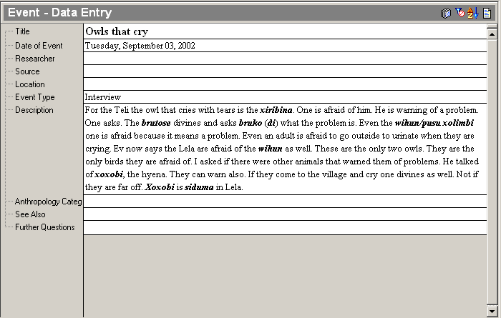

Exercise DM-2: Entering text in another language
Find the entry titled Kirihan’s thoughts on creation. It is dated 14 July 2002. In the Description field, click at the end of the sentence in the paragraph, and then press Enter. Enter the following Lela-Teli and French phrases using the appropriate writing system for each.
      - Using the Lela-Teli writing system, type or paste:
Duu duu duu naare

      - Press Spacebar.
      - Using the French writing system, type or paste:
- avant, avant, avant au début,

      - Press Spacebar.
      - Using the Lela-Teli writing system, type or paste:
nyelye powsi bruko

      - Press Spacebar.
      - Using the French writing system, type or paste:
- Dieu a créé (=versé) la terre. Il a mis un homme et une femme sur la terre. Les deux se sont mariés. Ils ont eu des enfants, et leurs enfants ont eu des enfants, etc.

      - Press Spacebar.
      - Using the Lela-Teli writing system, type or paste:
ba ara bokun, ba ara bo kun, ba ara bokun...

      - Press Enter.
      - Using the French writing system, type or paste:
Kirihan ne savait pas de quelle manière Dieu avait crié l'homme et la femme.

When you have finished, it should look like the example.
If you desire, you can fill in more fields using skills learned in other modules. Additional information is not provided.

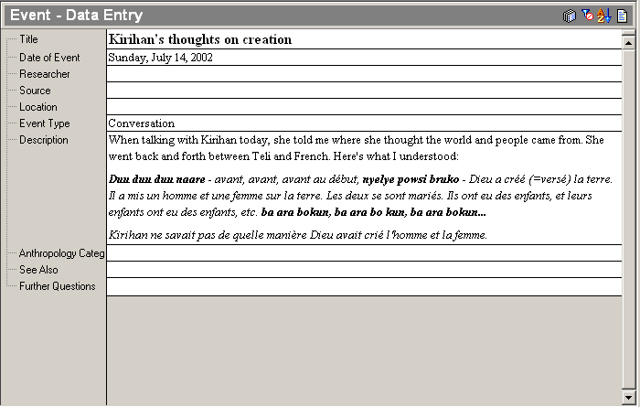

Module AD: Altering Data

Exercise AD-1: Adding text
Find the entry titled First funeral that is dated 14 September 2001. Find the subentry titled Various activities. Click the sign in the side bar to see the entire subentry.
Click after the word food in the sentence, A woman is setting up a tray of food down below me. M says it's for sale. Add the text, using the Added Text style, (I’ve learned they were beignets selling for 10cfa a piece.) Don’t forget the space, parentheses, and period.
When you have finished, it should look like the example below. If you desire, you can fill in more fields using skills learned in other modules. Additional information is not provided.
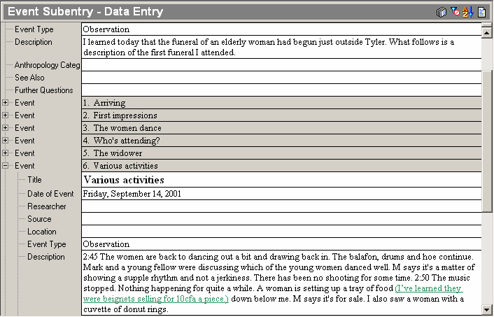

Exercise AD-2: Deleting and adding text
Find the entry titled Getting back the brideprice. It is dated 28 February 2002.
At the end of the sentence, He married a woman and had 4 children apply the Deleted Text style to the words 4 children. Add the text, using the Added Text style, (5 children). Don’t forget the space and parentheses.
When you have finished, it should look like the example below. If you desire, you can fill in more fields using skills learned in other modules. Additional information is not provided.
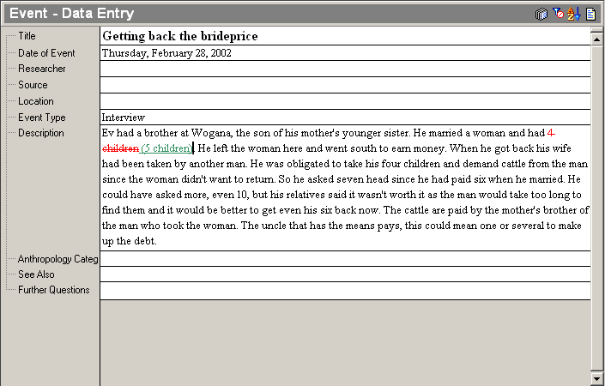

Module DQ: Using Your Data to Generate Research Questions

Exercise DQ-1: Entering questions
Find the entry titled Ev’s initiation. It is dated 23 February 2002. Add the following questions:

All the references are to the patriclan. Is it the patriclan that organizes the initiation? Does the matriclan have anything to do with it?
Was it a 'bad day' because of all the hitting and insulting had started, or for some other reason?
Did the school have anything to say about some children missing so much school?

When you have finished, it should look like the example below. (We have deleted approximately the last 24 sentences of the Description field so you can see the result). If you desire, you can fill in more fields using skills learned in other modules. Additional information is not provided.
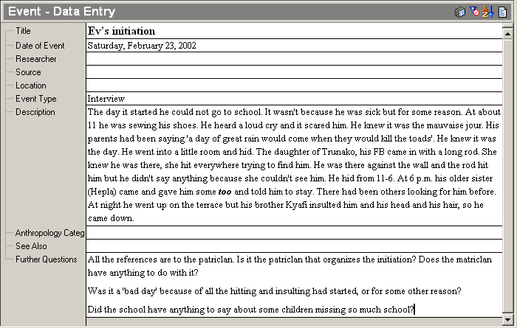

Exercise DQ-2: Entering questions
Find the entry titled Patriclan responsibilities for dancing at a funeral. It is dated 23 February 2002. Add the following questions:

Why do the officials want to dance the duya? Do they know what they are dancing?
What are people afraid of as regards the officials?

When you have finished, it should look like the example below. If you desire, you can fill in more fields using skills learned in other modules. Additional information is not provided.

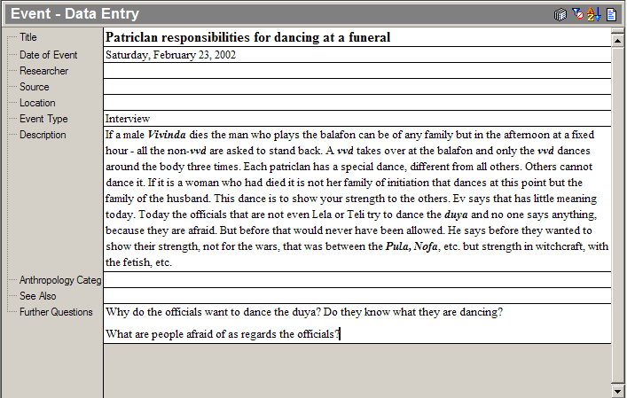

Module CE: Categorizing Entries

Exercise CE-1: Adding OCM codes
Find the entry titled A man’s field. It is dated 29 August 2002. Add OCM categories. Find the appropriate OCM Categories using the Index. Suggested topics: Agriculture, Cotton, Tools, and Family. Feel free to use other applicable topics that appear in the Index pane.
When you have finished, it should look like the example below. If you desire, you can fill in more fields using skills learned in other modules. Additional information is not provided.

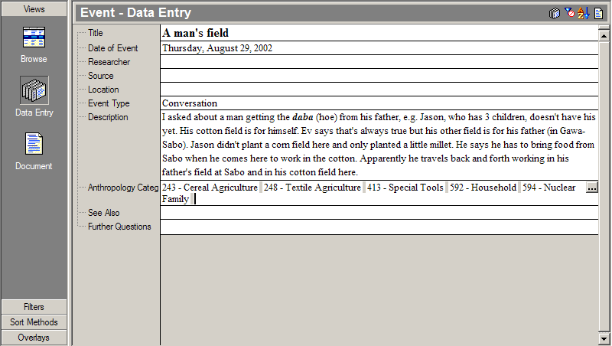

Exercise CE-2: Adding OCM codes
Find the entry titled Interrogation of the body. It is dated 10 June 2002. It is a subentry of Senra’s Funeral dated 10 June 2002. Add OCM categories. Find the appropriate OCM Categories using the Index. Suggested topics: Funeral, Revelation and Divination, Ritual, and Magicians and Diviners. Feel free to use other applicable topics that appear in the Index pane.
When you have finished, it should look like the example below. If you desire, you can fill in more fields using skills learned in other modules. Additional information is not provided.

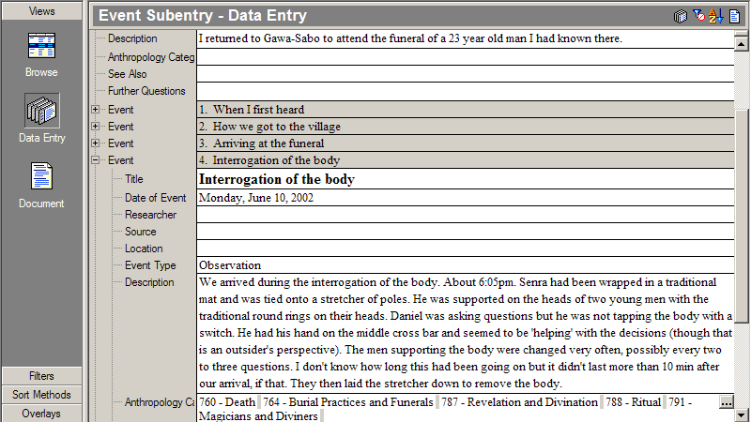

Exercise CE-3: Adding more OCM codes (optional)
You can add OCM codes to other entries you have seen in previous modules. If you want to compare your selection with someone else’s work then open the Lela-Teli 3 project. Find the corresponding entry and compare your OCM selections in the Lela-Teli 2 project to those found in Lela-Teli 3. When you are finished close the Lela-Teli 3 project.

Module OL: Identifying Data with Overlays

Exercise OL-1: Tagging texts with overlays
Find the entry titled The balafon and the fetishes. It is dated 21 September 2001.
      - Tag the following text portion with the 778 Sacred objects and places tag using the Relating to the supernatural overlay.
I was asking Jason about the balafon used at funerals and how they were related to the fetish.
      - Tag the following text portion with the 788 Ritual tag using the Relating to the supernatural overlay.
He said that when they were made there was no fetish in them, but then a diviner did a ceremony and invited the fetish in so the instrument could be used at funerals.
      - Tag the following text portion with the 772 Cosmology tag using the Relating to the supernatural overlay.
When the music is played it is the fetish talking, even though it is a man playing the instrument.
      - Tag the following text portion with the 781 Religious Experience tag using the Relating to the supernatural overlay.
He said that that is why Christians don't use the balafon in church...because of the fetish. I asked why they couldn't use it before the ceremony to call the fetish was done, but he said, "No, everyone would believe that there was a fetish inside and be afraid of it."
      - Tag the following text portion with the 796 Organized Ceremonial tag using the Relating to the supernatural OVERLAY.
They only used drums and rattles in church. I remembered that Ev always shook a rattle when we sang during a service.

Exercise OL-2: Tagging texts with overlays
Find the entry titled Consulting the fetish after a funeral. It is dated 07 March 2002.
      - Tag the following text portion with the 788 Ritual tag using the Relating to the supernatural overlay.
It is the third day for men and the 4th day for women. The family meets with the diviner in the room of the dead person. Others from the village may listen outside. The diviner sits facing the door and looks out. The rest sit around where they want. It's not important who sits next to the diviner.
      - Tag the following text portion with the 781 Religious Experience tag using the Relating to the supernatural overlay.
He talks to his fetish and interrogates him calling the name of the dead person. He first asks if he is well arrived and if there's news for the house. He asks if all is well in the house. He asks the fetish Tilkha if the dead has done anything bad
      - Tag the following text portions with the 788 Ritual tag using the Relating to the supernatural overlay.
and then he asks the other diviners of the house, citing their names and asks if all is well with the dead, is there anything wrong. Each man is called and asked yes or no. If 'yes, he has done something wrong', theft, sorcery, etc. The diviner asks what he has done.
      - Tag the following text portion with the 781 Religious Experience tag using the Relating to the supernatural overlay.
If the dead says he's not arrived well he is asked what he has done wrong that he didn't find the right road.
      - Tag the following text portions with the 772 Cosmology tag using the Relating to the supernatural overlay.
The person who has died has become like the fetish, a spirit.
      - Tag the following text portions with the 788 Ritual tag using the Relating to the supernatural overlay.
If he says he has arrived well among the ancestors then he is asked what caused his death. The diviner takes his left hand and takes the right hand of whoever is at his left. 'No' is when the two hands slap across his leg. 'Yes' is when the 2 hands dip to the floor. Then to check the answers he tosses out cowries. He throws 2,3 or up to 10. He said 5 is probably most often. All tosses are 'no' except when one out of the lot only is with the smooth side up and all the rest are turned with the crease up.
      - When you have finished, close the Overlay dialog box. If you want more practice, you can apply this overlay in other entries. Additional information is not provided.

Module AS: Adding Supporting Evidence

Exercise AS-1: Adding supporting evidence
Find the entry titled Some notes about the matriclan. It is dated 5 January 2002. In the Supporting Evidence field, create cross-reference links to the following event entries:
- The matriclan and the patriclan dated 30 December 2001
- The matriclan dated 4 June 2002
- The matriclan and children dated 3 June 2002
- The story of two sub-matriclans dated 3 June 2002
When you have finished, it should look like the example below. If you desire, you can fill in more fields using skills learned in other modules. Additional information is not provided.

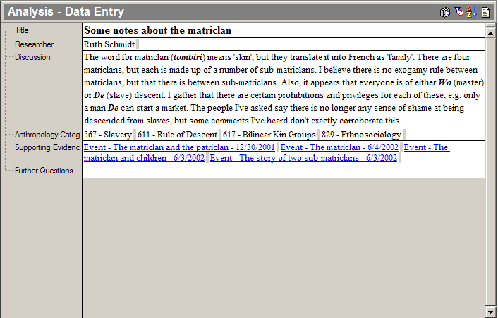

Exercise AS-2: Adding supporting evidence
Find the entry titled Some thoughts on the fetish. It is dated 25 July 2002. In the Supporting Evidence field, create cross-reference links to the following event entries:
- Distinguishing some fetishes dated 24 July 2002
- Membership in the patriclan dated 4 January 2002
When you have finished, it should look like the example below. If you desire, you can fill in more fields using skills learned in other modules. Additional information is not provided.

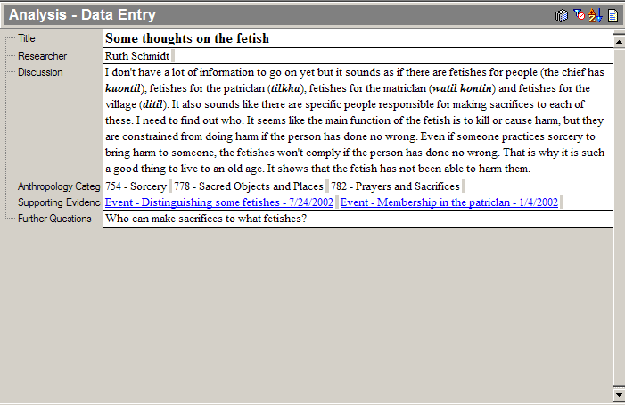

Module BF: Using Basic Filters to Find Data

Exercise BF-1: Applying a basic filter
You might want to look over all the material you have gotten from one source, so that you can compare it to material you received from another. To do this, apply an existing basic filter called Source, and then and look for certain people (remember Module TP). Apply the filter for the following names (or as many as is necessary to feel comfortable with the task):
Jason, Lester, Nathan, Paul, and Susan

Exercise BF-2: Creating a basic filter
At some point during your research, you may want to review specific material you have collected on a topic that is narrower than a given OCM category. For instance, the OCM category 776 Spirits and Gods would apply to much more than just the term fetish. To find only material related to this word create a new basic filter called Fetish in which the Description field must contain the word fetish. Create and apply the filter. Check numerous filtered event entries to see if you can find the word fetish in the Description field.
Tip: Switch to Document view to search multiple entries.
Make sure you turn off the filter before continuing. (Click the No Filter icon).

Module AF: Adding and Using Advanced Filters

Exercise AF-1: Creating an advanced filter
Create a new advanced filter called matriclan. It must filter for the following factors:
- Event and Analysis entries – It must include both types of entries.
- Anthropology categories – The data about lineages is marked with the OCM code 617 Bilinear Kin Groups and the OCM code 618 Clans. Both categories must be included in the filter.
- Matriclan – In order to eliminate data that is exclusively about patriclans, the filter must be configured to look for the word matriclan in various text fields. These text fields are Title, Description, and Discussion.
When you have finished creating the filter, the matriclan – Expanded Advanced Filter Table dialog box should look like the example below.
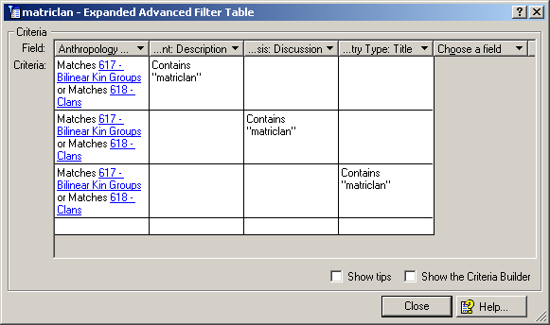

Apply the filter. Check numerous event entries to see if you can find the word matriclan in the appropriate fields
Make sure you turn off the filter before continuing. (Click the No Filter icon).

Exercise AF-2: Creating an advanced filter
Additional criteria can be added to an already complex filter. Additional columns can narrow the scope of data. Additional rows can expand the scope of the data. For example, besides filtering for a specific topic (that is, patriclans), you may also want to limit the sources of that data to one or two people.
Create a new advanced filter called Patriclan sources that is similar to the Patriclan filter. You want to filter to match only the following two sources:
- a publication by Felton
- a local resident named Everett
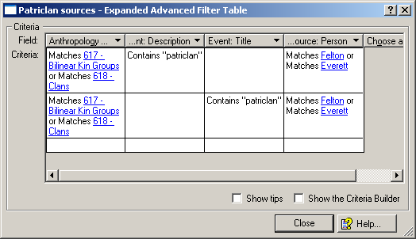
When you have finished creating the filter, the Patriclan sources – Expanded Advanced Filter Table dialog box should look like the example below.

Apply the Patriclan sources filter, and then apply the Patriclan filter. Compare your results.

Tip: Filter criteria for text fields often consist of a word or phrase that the field contains. Filter criteria for list reference fields often match specific items (for example, 617 - Bilinear Kin Groups in the Anthropology Categories field, Felton in the Source field).

